18.82: 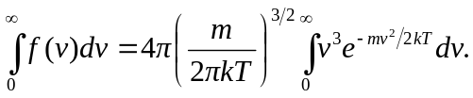

Making the suggested change of variable, 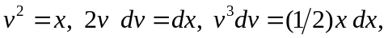 the integral becomes

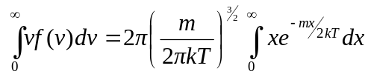

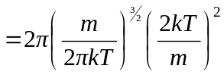
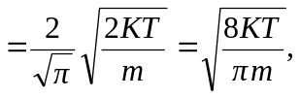
which is Eq. (18.35).

